**JAVA FULLSTACK TASK -1**

Name: KM KIRTHICKRAJ

Dept : EEE-3rd year

Clg :KSR IET

Date :11.07.24

GIT LAB ASSIGNMENT -1

1. Create a local git repo with the name"MyRpo".

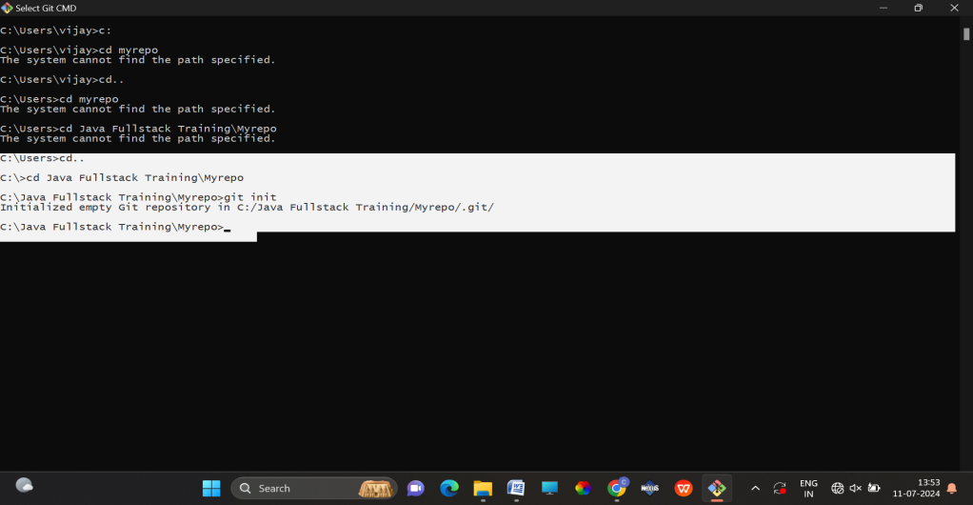

1. create one .txt file, five .c files and five .java files in the working area.

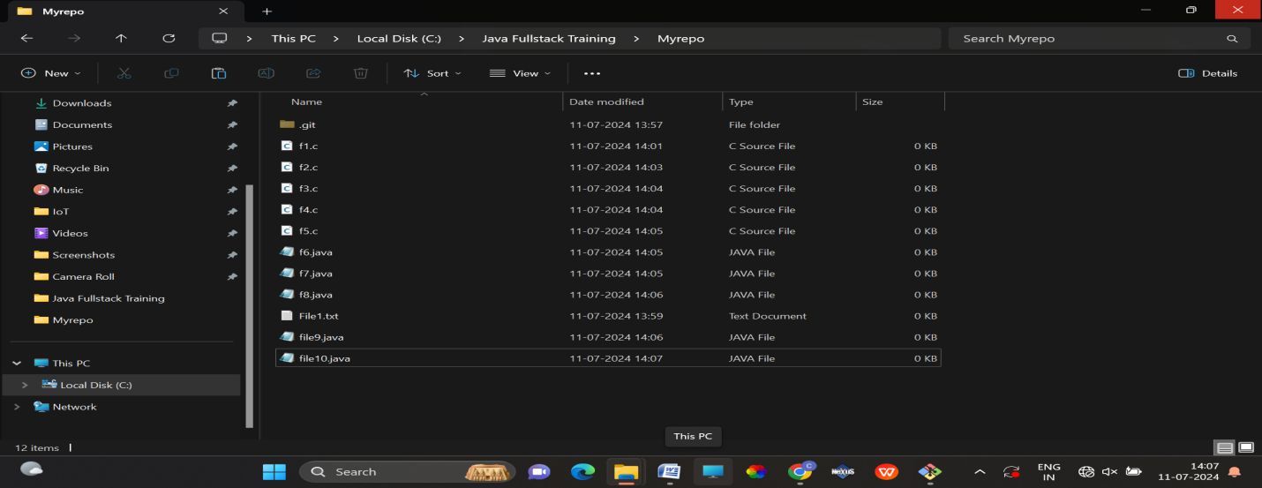

3.Verify the git status

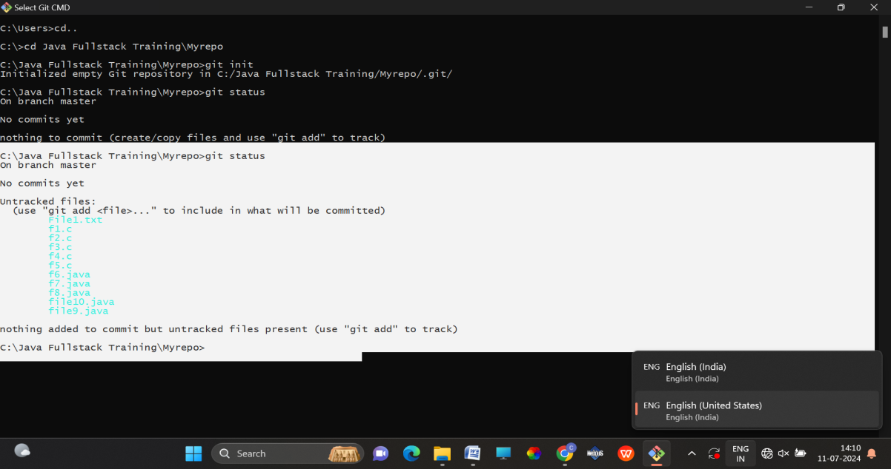

4.Add only the .txt into

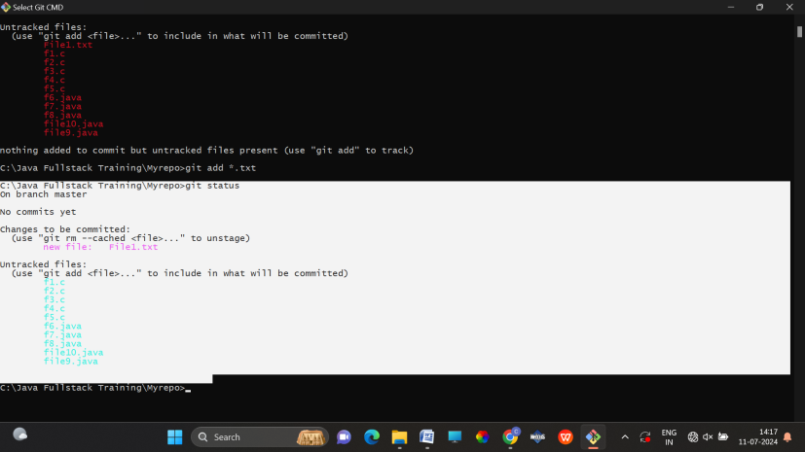

5. verify the git status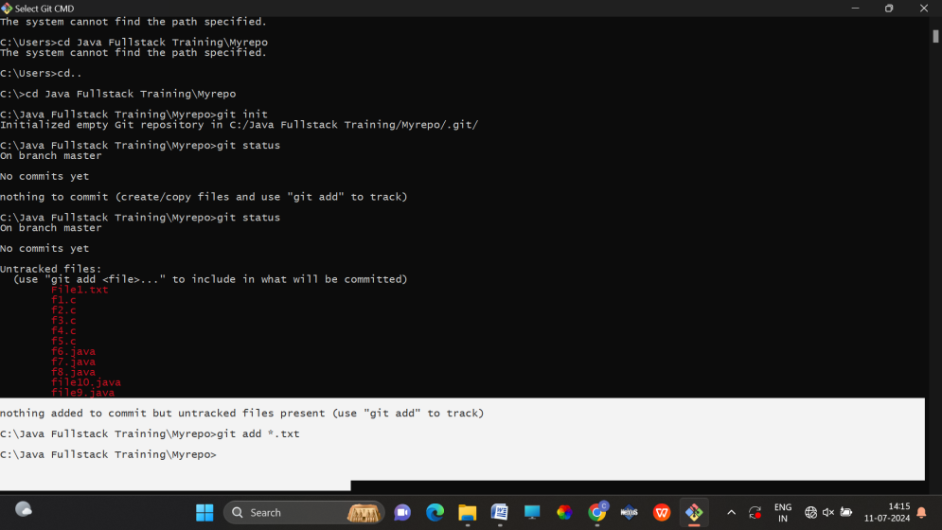

6. Make a commit with the name "TXT Commit"

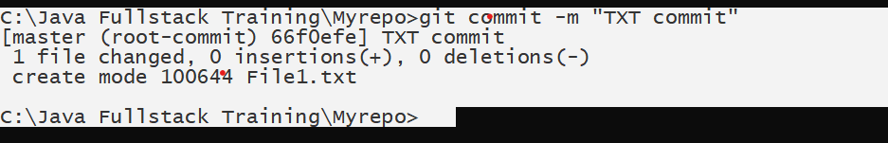

7. Add all .c files into the staging area

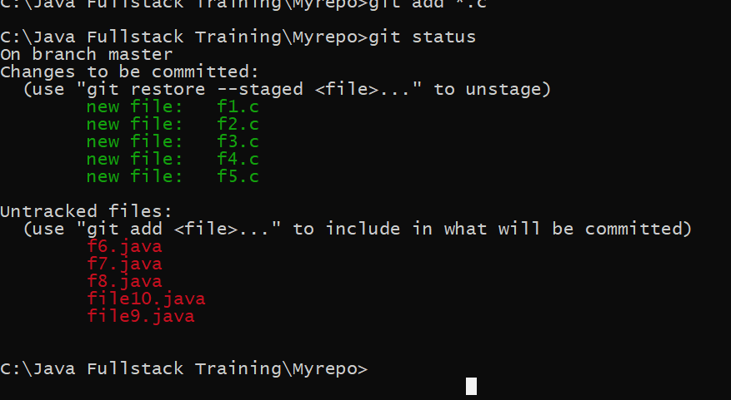

8. verify the git status

9. Make a commit with the name "C Commit"

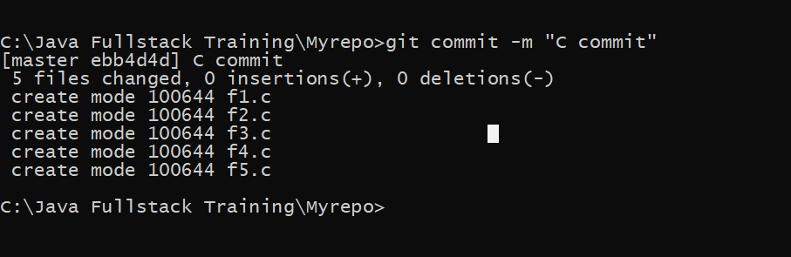

10 .Add all .java files into the staging area .

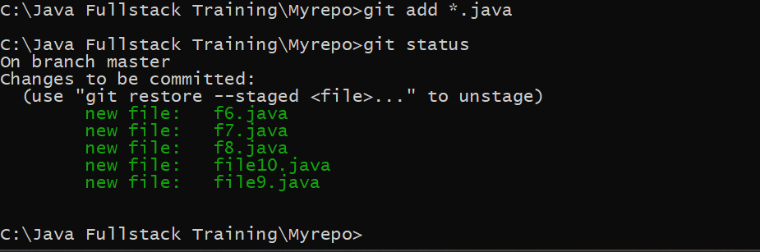

11. verify the git status

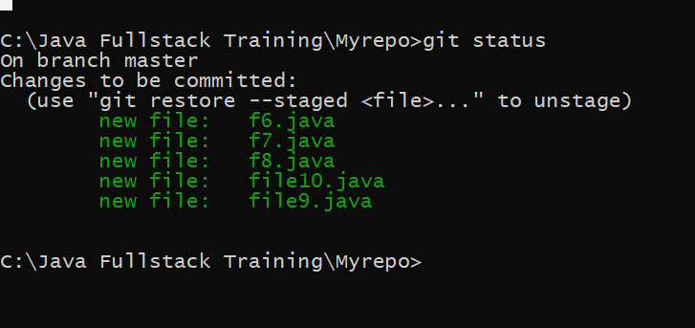

12. Make a commit with the name "Java Commit"

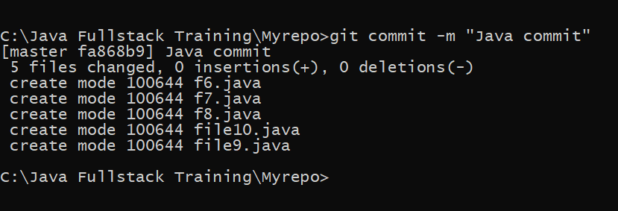

13. Delete all .java files from working area

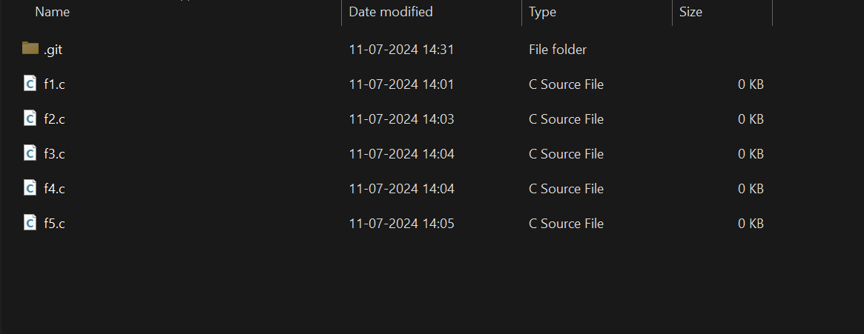

14. Now see the status

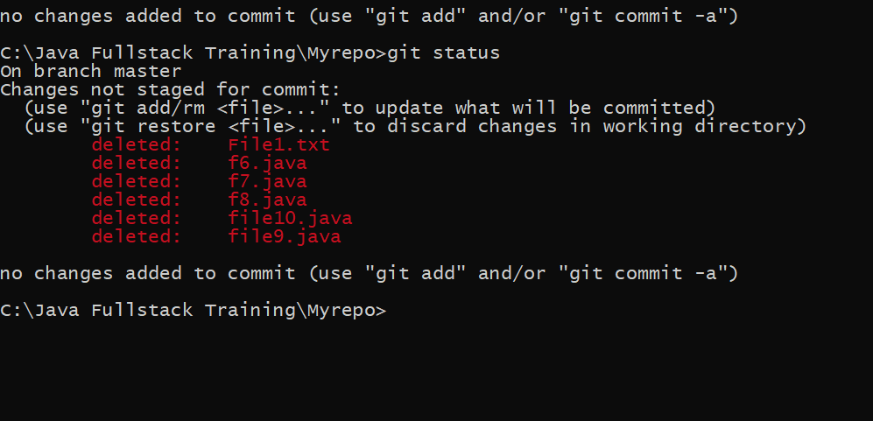

15. add the changes into the staging area.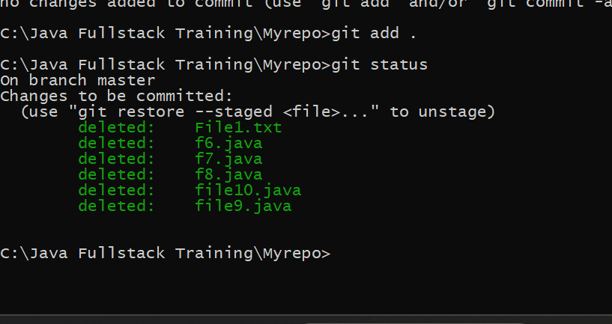

16. Make a commit with the name "Delete Java Commit"

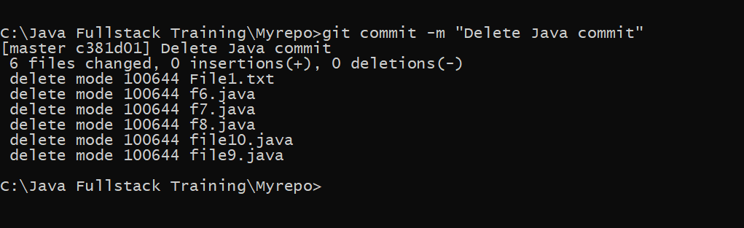

17. display all commit details

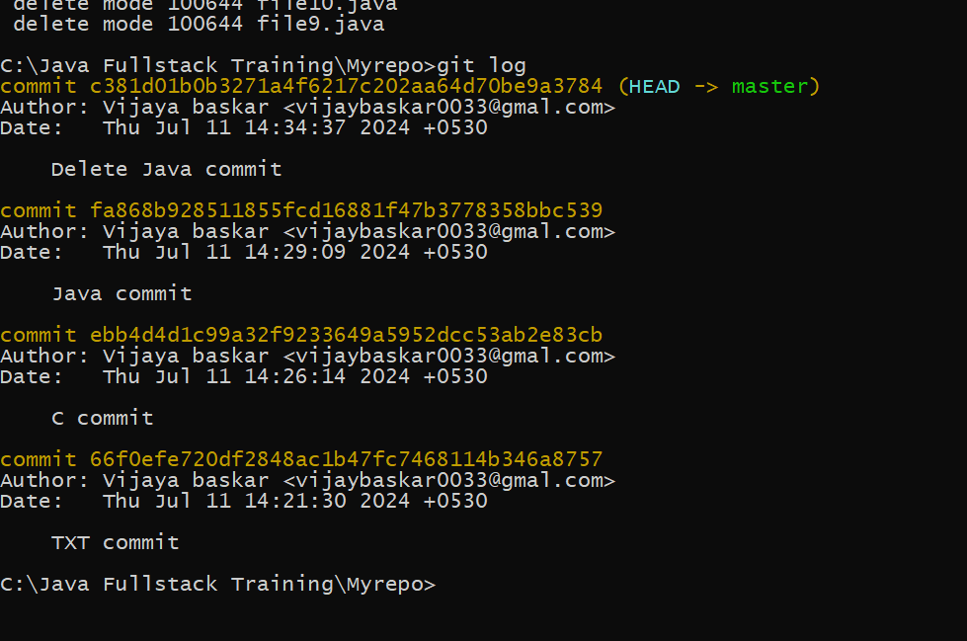

DAY-2

1.Create a new directory and change into it.

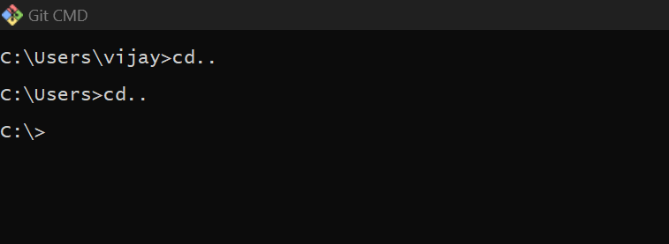

2.Use the **init** command to create a Git repository in that directory.

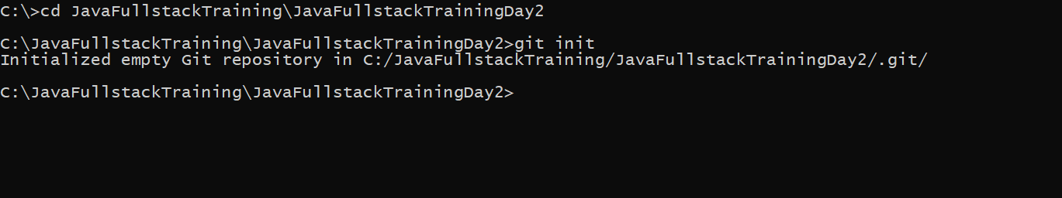

3.Observe that there is now a **.git** directory.

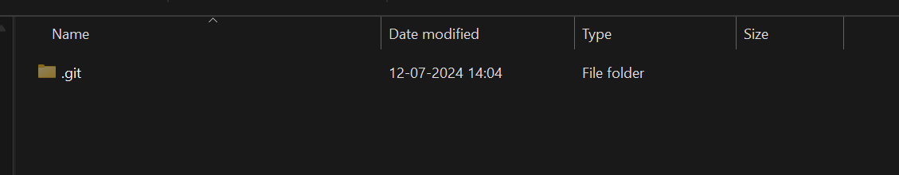

4.Create a **README** file

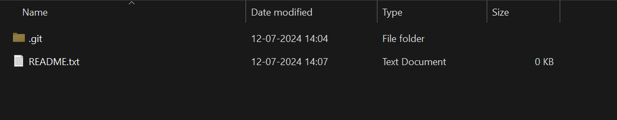

5. Look at the output of the **status** command; the **README** you created should appear as an

untracked file.

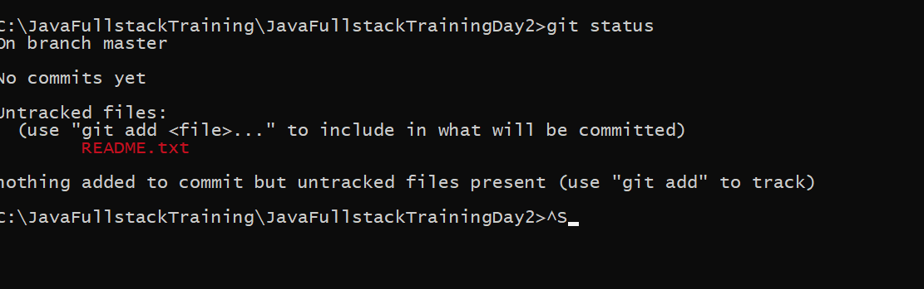

6. Use the **add** command to add the new file to the staging area. Again, look at the output of

the **status** command.

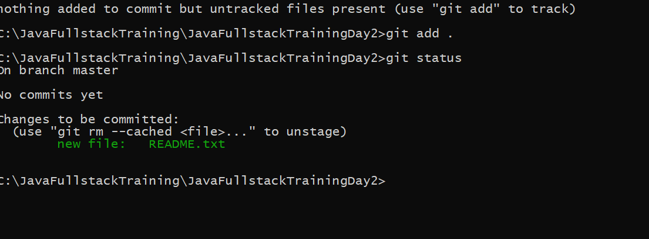

7. Now use the **commit** command to commit the contents of the staging area.

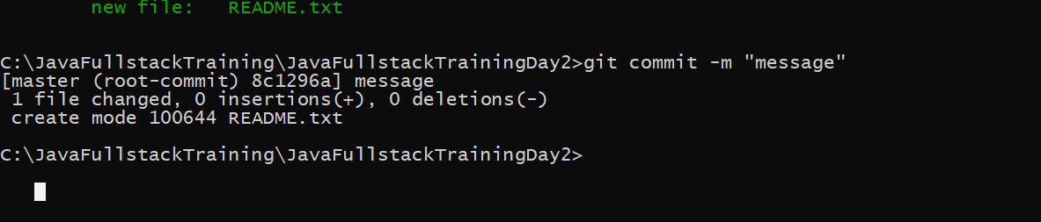

8. Create a **src** directory and add a couple of files to it.

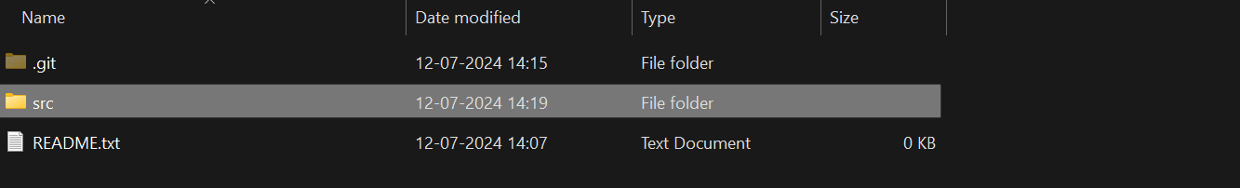

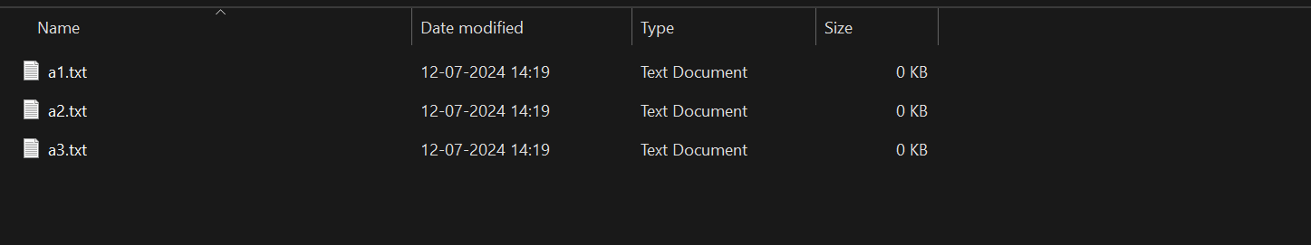

9. Use the **add** command, but name the directory, not the individual files. Use the **status**

command. See how both files have been staged. Commit them.

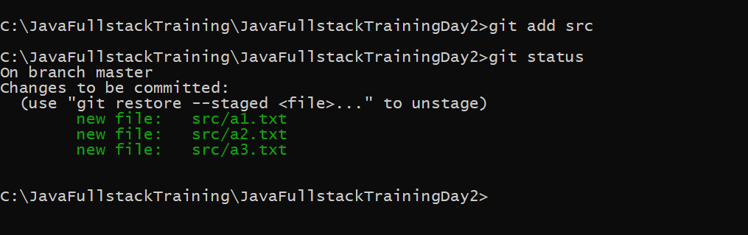

10. Make a change to one of the files. Use the **diff** command to view the details of the change.

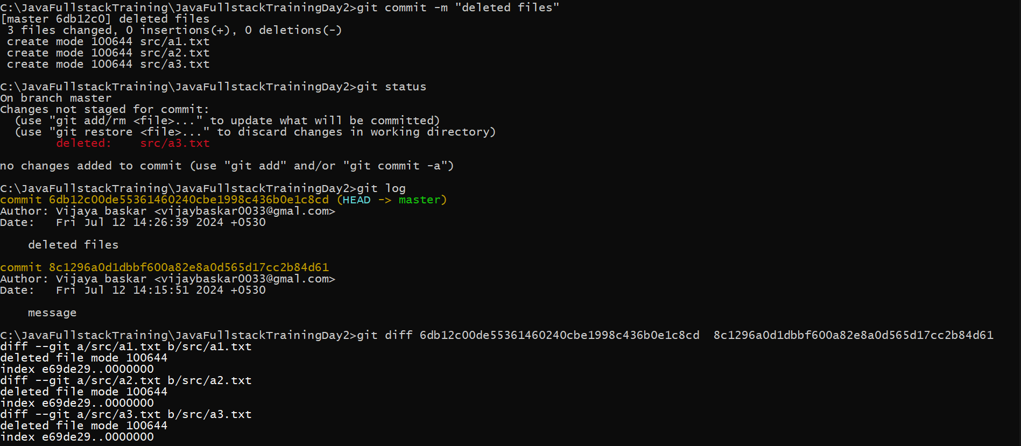

11. Next, **add** the changed file, and notice how it moves to the staging area in the **status**

output. Also observe that the **diff** command you did before using add now gives no output.

Why not? What do you have to do to see a **diff** of the things in the staging area? (Hint:

review the slides if you can’t remember.)

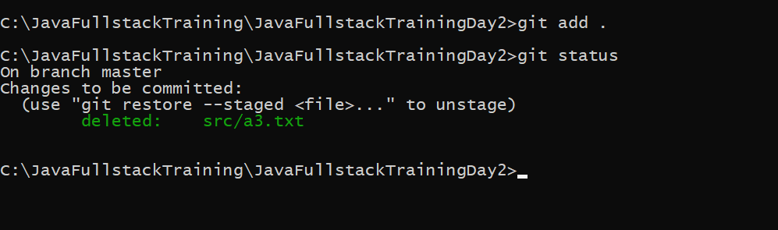

12. Now – without committing – make another change to the same file you changed in step 10.

Look at the **status** output, and the **diff** output. Notice how you can have both staged and

unstaged changes, even when you’re talking about a single file. Observe the difference when

you use the **add** command to stage the latest round of changes. Finally, **commit** them. You

should now have started to get a feel for the staging area.

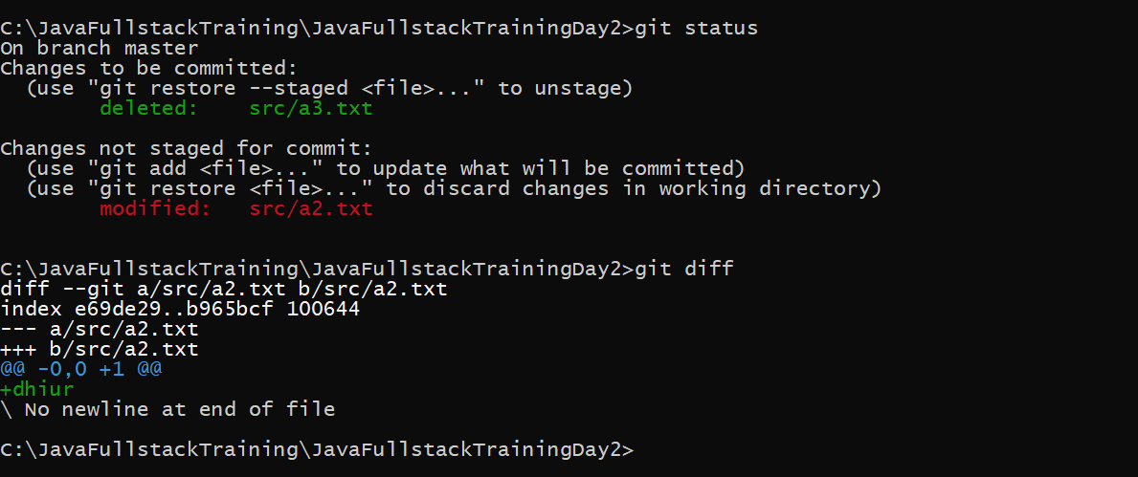

13. Use the **log** command in order to see all of the commits you made so far.

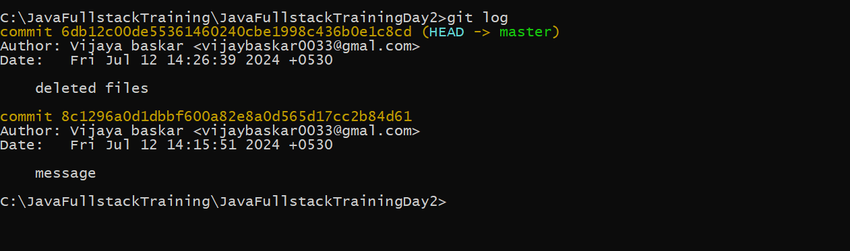

14. Use the **show** command to look at an individual commit. How many characters of the

commit identifier can you get away with typing at a minimum?

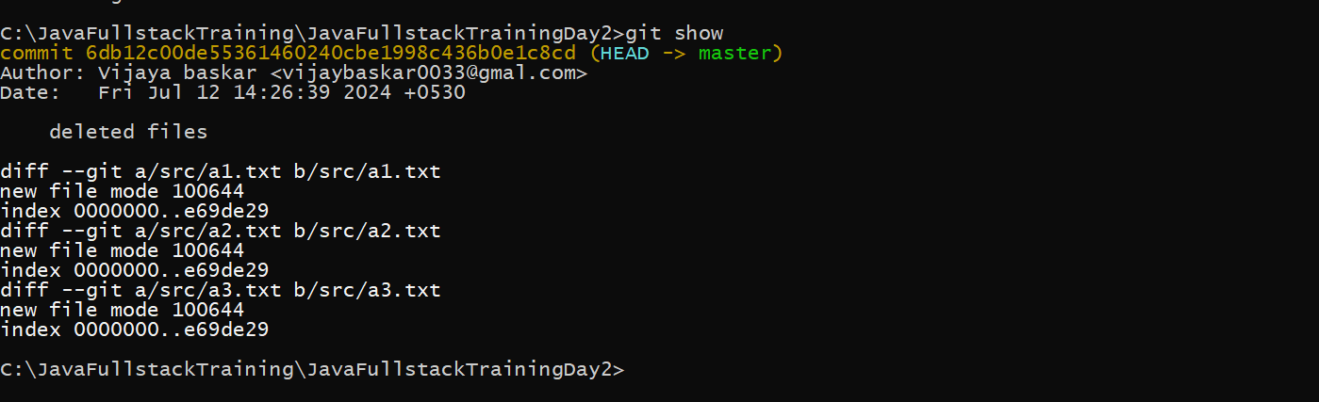

15. Make a couple more commits, at least one of which should add an extra file.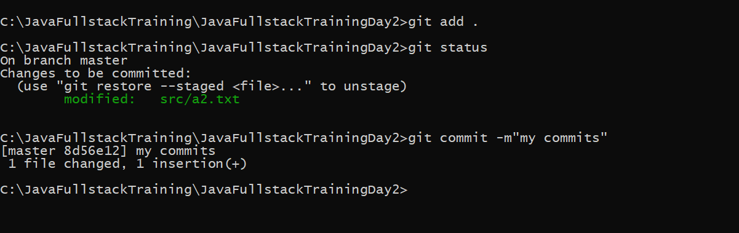

**DAY-2**

**ASSIGNMENT-2**

1.Run the **status** command. Notice how it tells you what branch you are in.

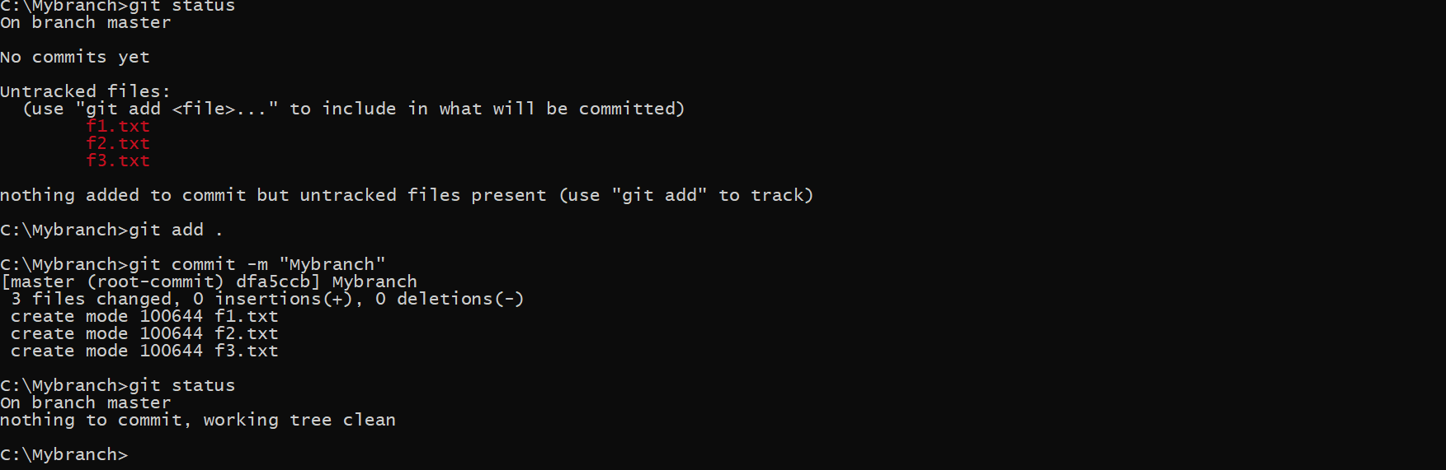

2.Use the **branch** command to create a new branch.

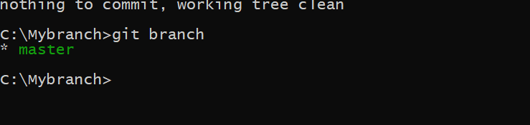

3.Use the **checkout** command to switch to it.

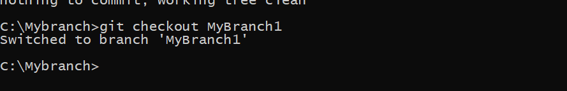

4. Make a couple of commits in the branch – perhaps adding a new file and/or editing existing

ones.

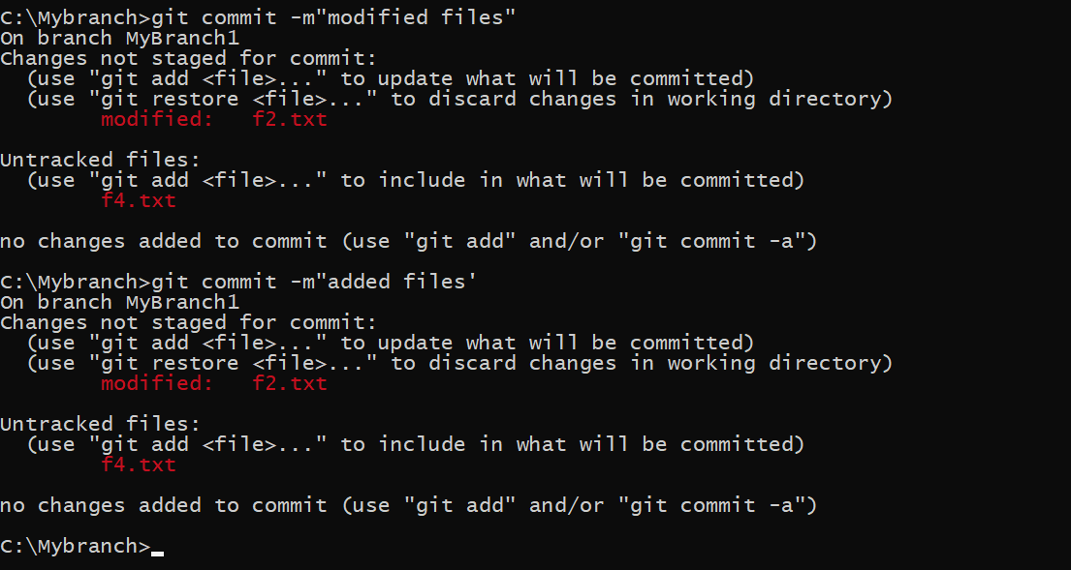

5. Use the **log** command to see the latest commits. The two you just made should be at the

top of the list.

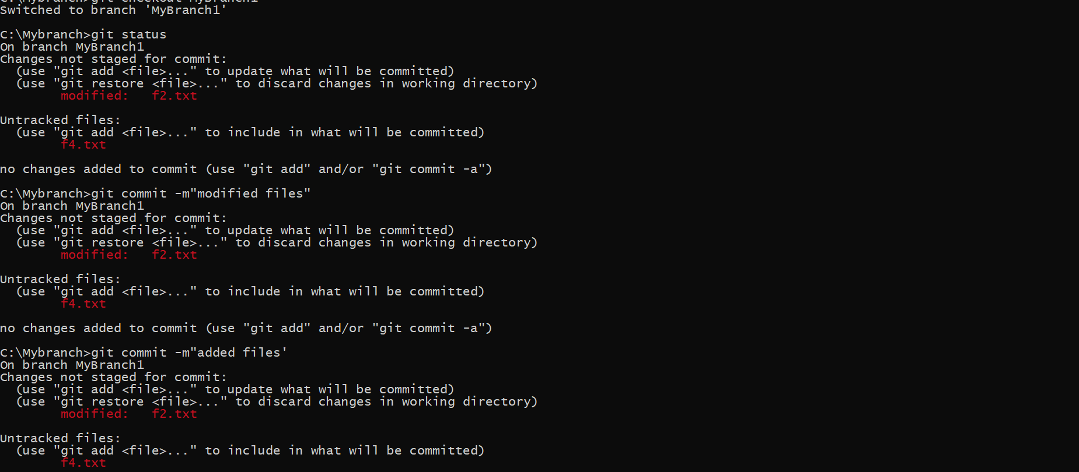

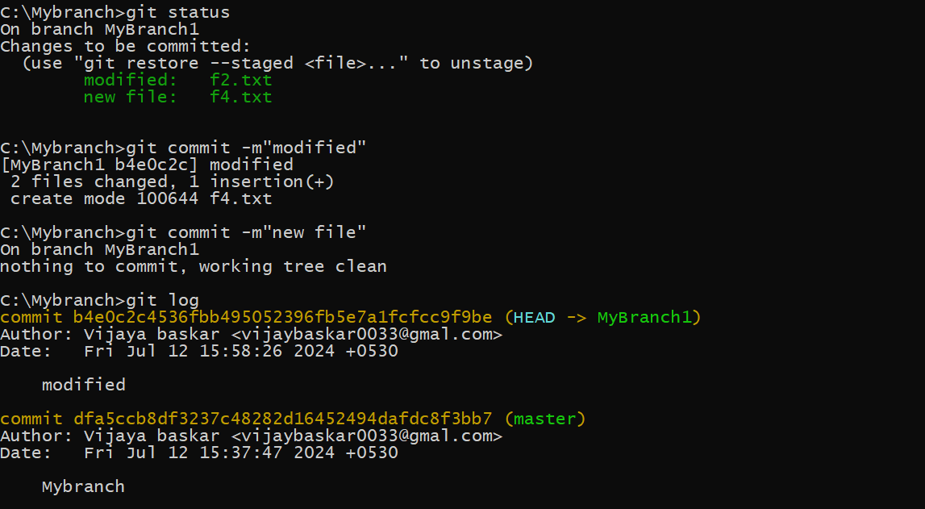

6. Use the **checkout** command to switch back to the master branch. Run **log** again. Notice

your commits don’t show up now. Check the files also – they should have their original

contents.

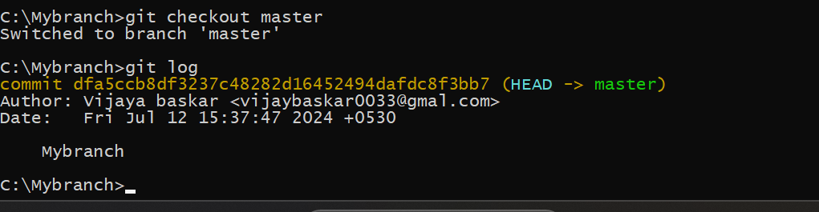

7. Use the **checkout** command to switch back to your branch. Use **gitk** to take a look at the

commit graph; notice it’s linear.

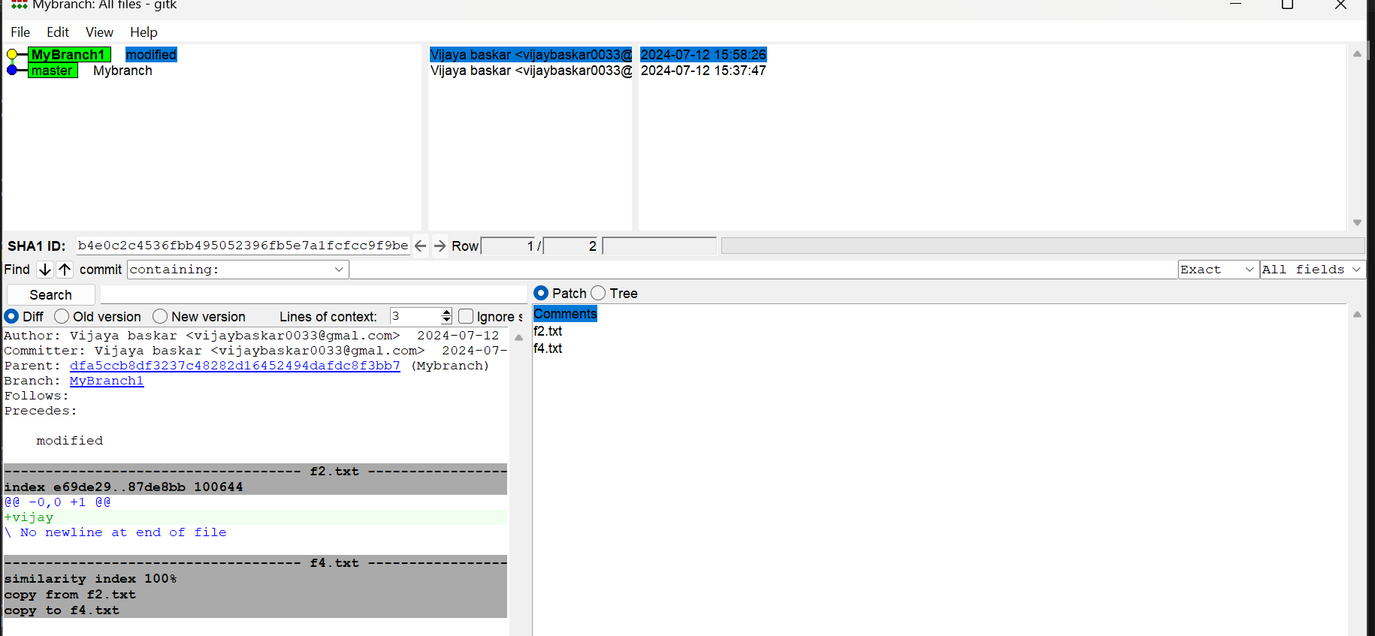

8. Now **checkout** the master branch again. Use the **merge** command to merge your branch in

to it. Look for information about it having been a fast-forward merge. Look at **git log**, and

see that there is no merge commit. Take a look in **gitk** and see how the DAG is linear.

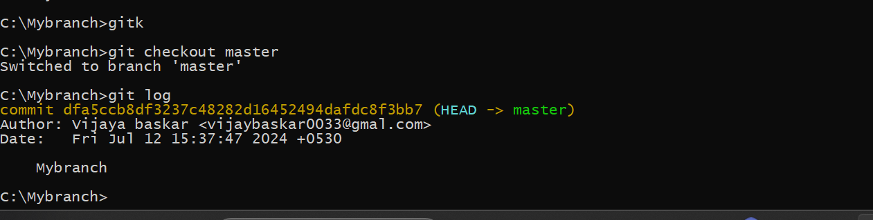

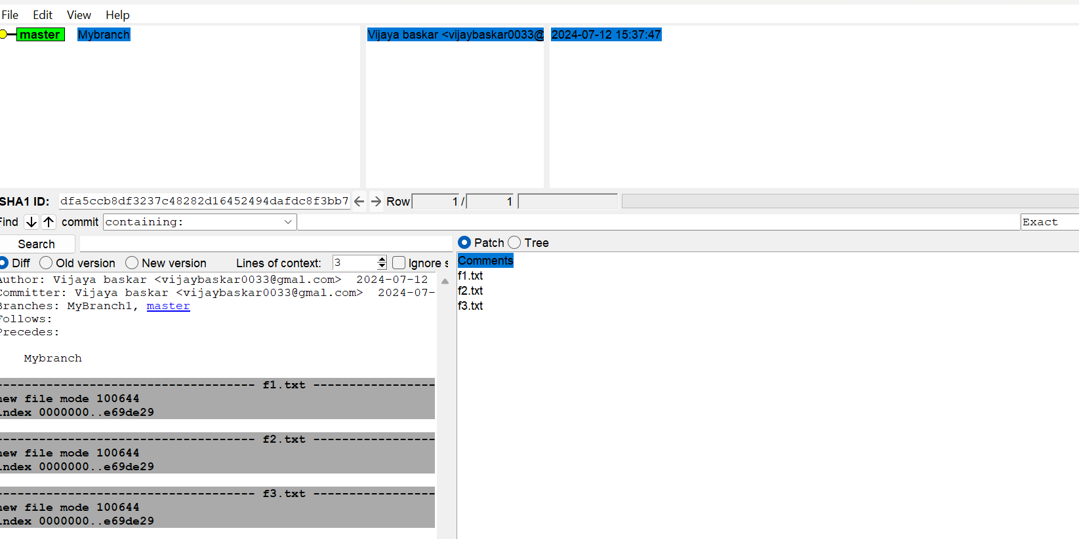

9. Switch back to your branch. Make a couple more commits.

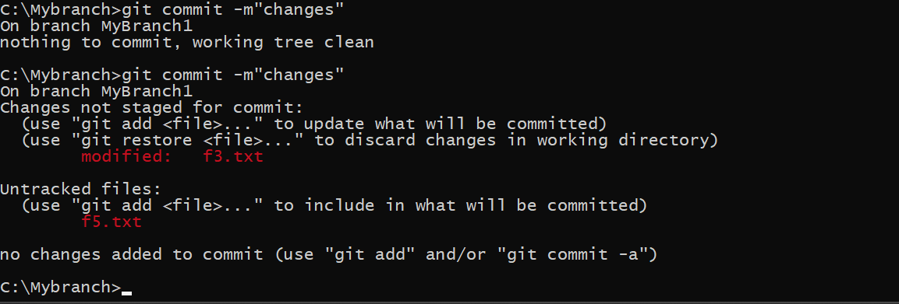

10. Switch back to master. Make a commit there, which should edit a different file from the

ones you touched in your branch – to be sure there is no conflict.

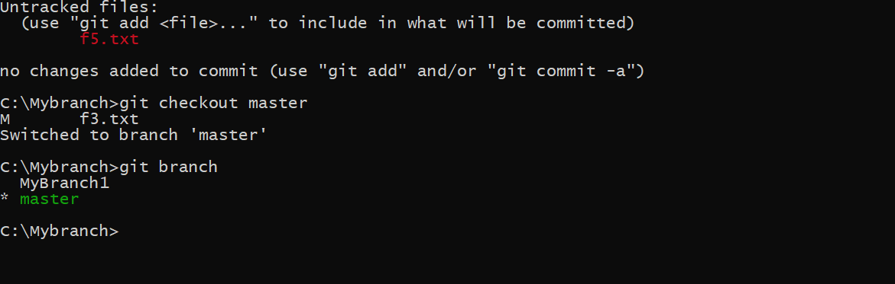

11. Now **merge** your branch again. (Aside: you don’t need to do anything to inform Git that you

only want to merge things added since your previous merge. Due to the way Git works, that

kind of issue simply does not come up, unlike in early versions of Subversion.)

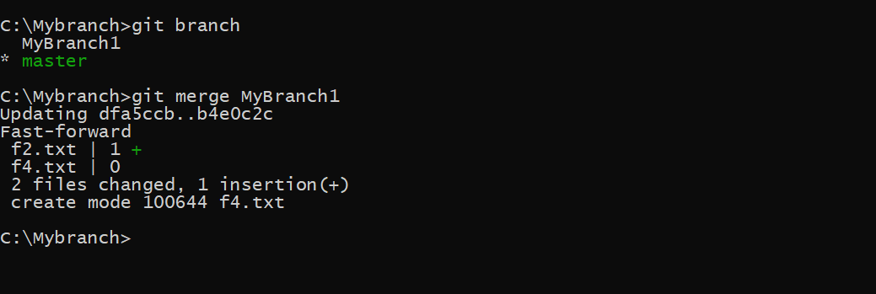

12. Look at **git log**. Notice that there is a merge commit. Also look in **gitk**. Notice the DAG

now shows how things forked, and then were joined up again by a merge commit.

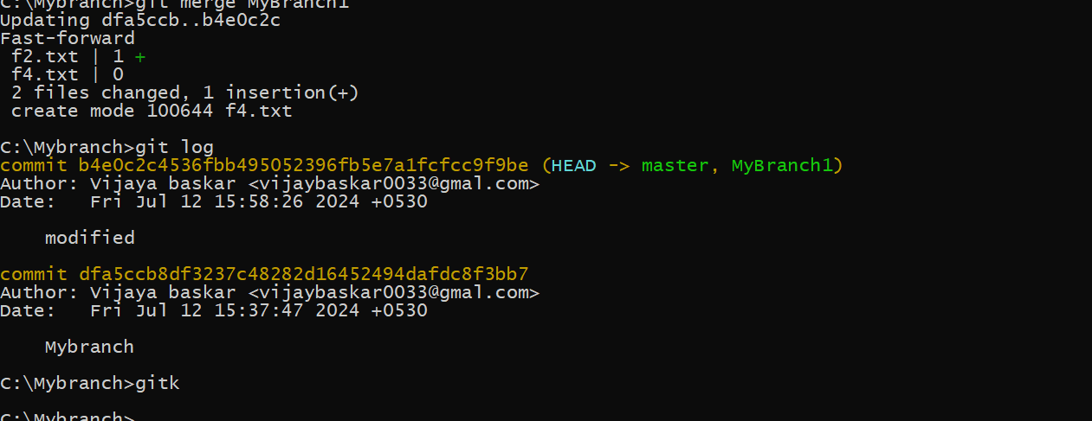

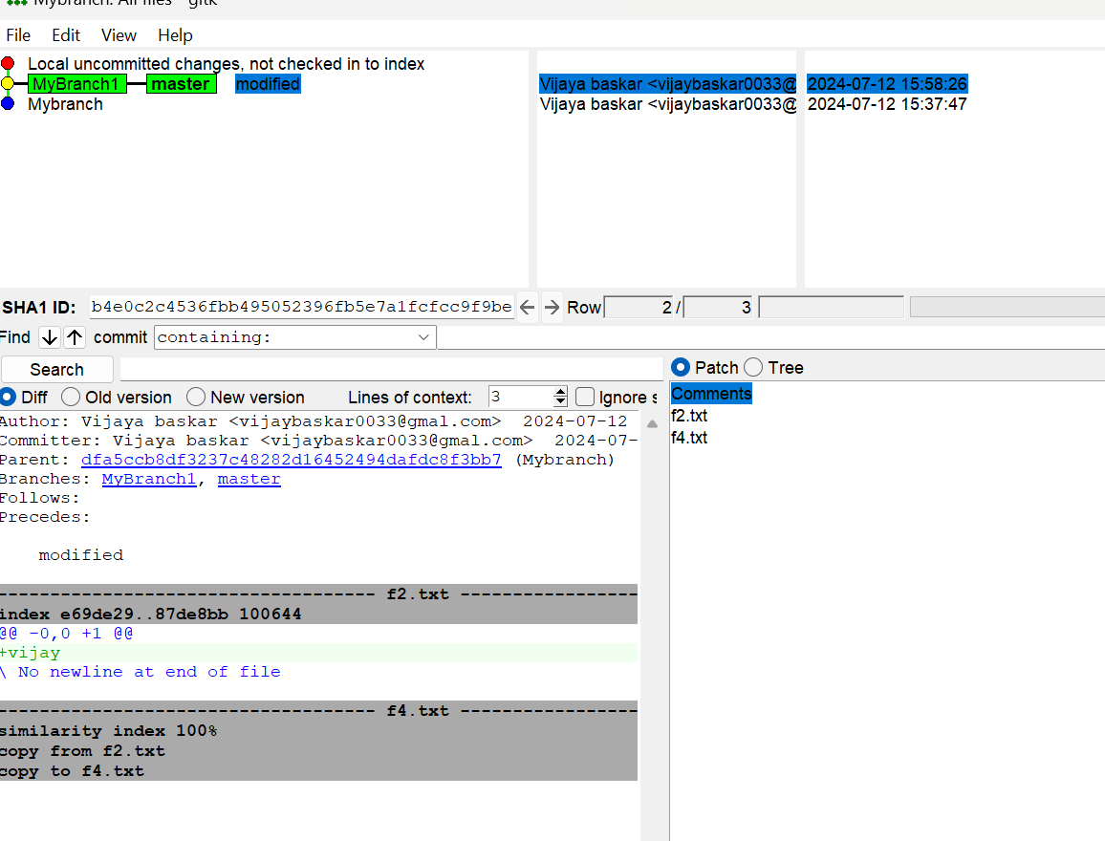

Exercise 3

1. First, one person in the group should create a public repository using their GitHub account.

2. This same person should then follow the instructions from GitHub to add a remote, and then push their repository. Do not forget the –u flag, as suggested by GitHub!

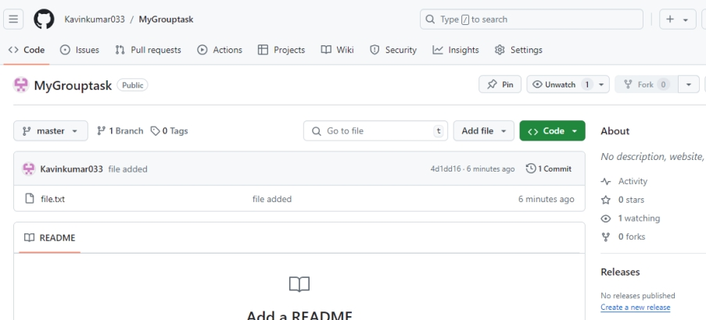

3. All of the other members of the group should then be added as collaborators, so they can commit to the repository also.

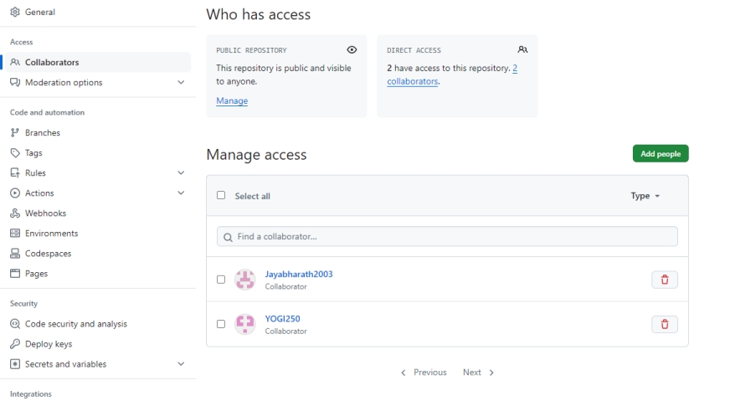

4. Next, everyone else in the group should clone the repository from GitHub. Verify that the context of the repository is what is expected.

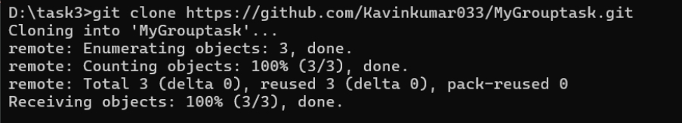

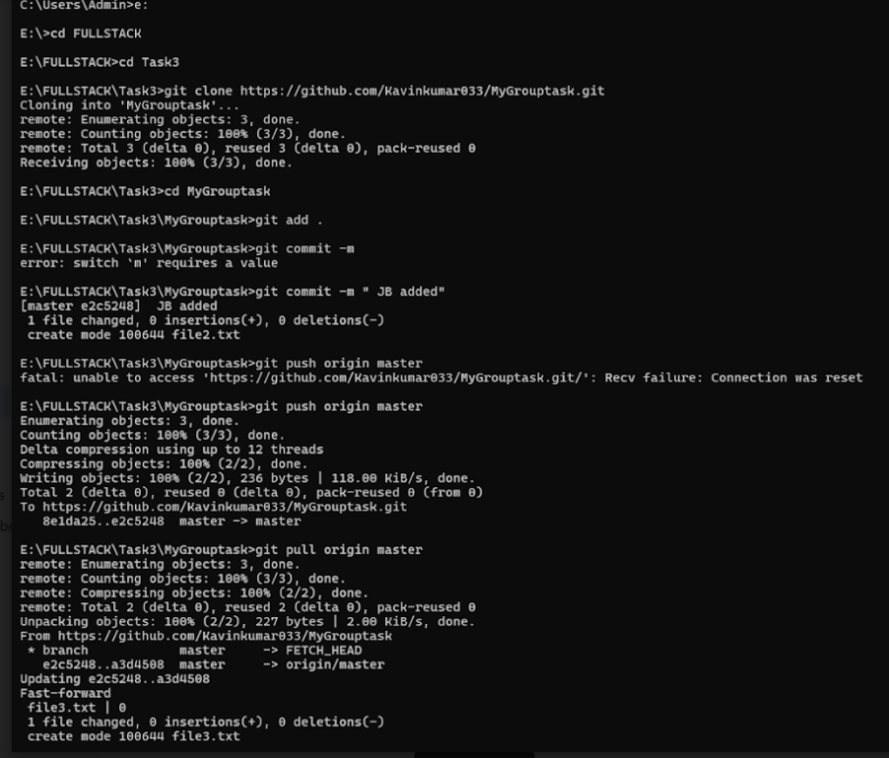

5. One of the group members who just cloned should now make a local commit, then push it. Everyone should verify that when they pull, that commit is added to their local repository (use git log to check for it).

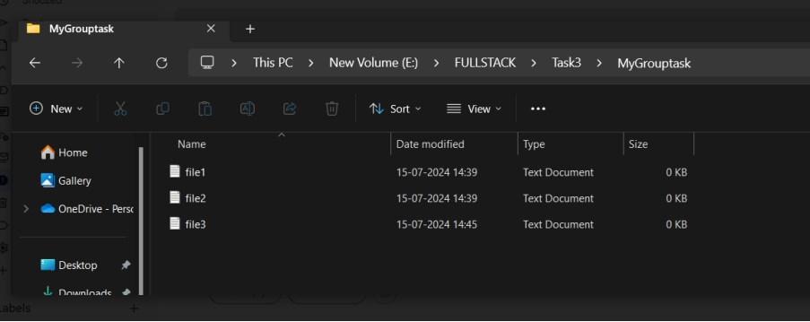

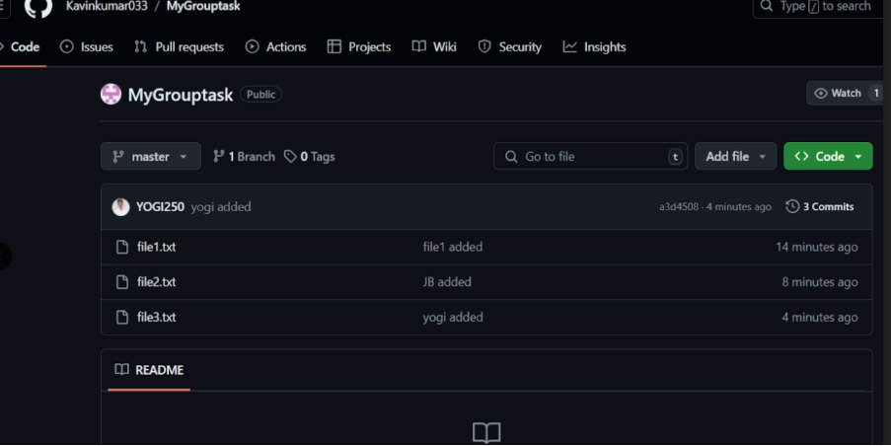

6. Look at each other’s git log output. Notice how the SHA-1 is the same for a given commit across every copy of the repository. Why is this important?

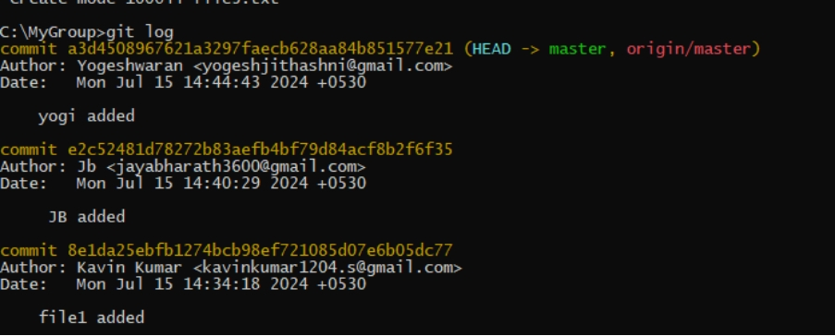

7. Two members of the group should now make a commit locally, and race to push it. To keep things simple, be sure to edit different files. What happens to the runner-up?

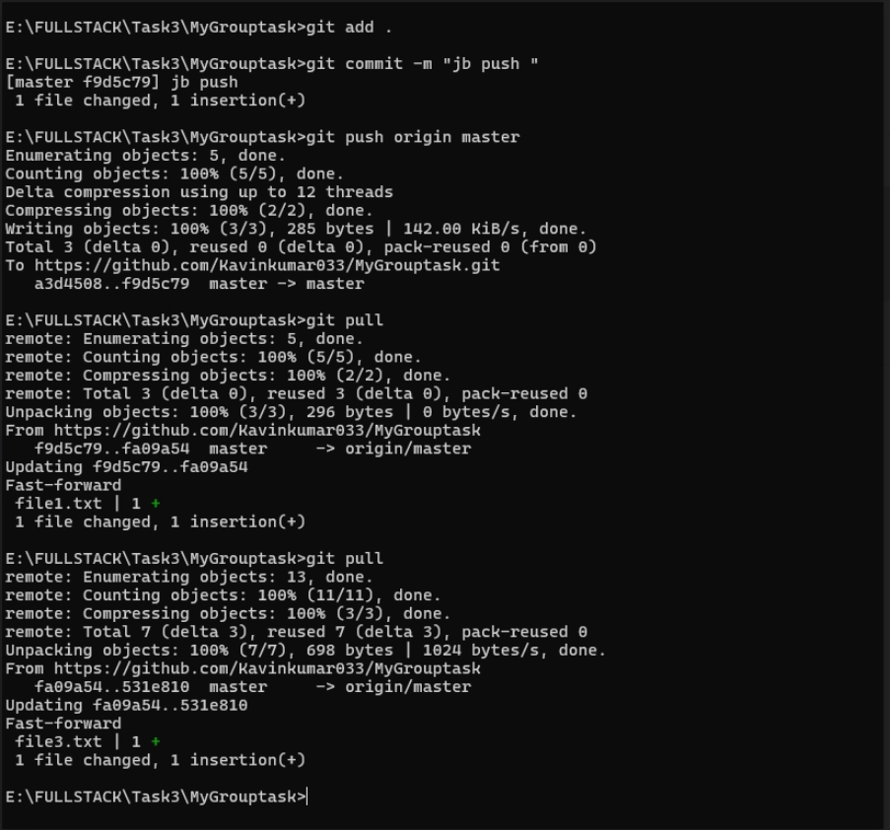

8. The runner-up should now pull. As a group, look at the output of the command. Additionally, look at the git log, and notice that there is a merge commit. You may also wish to view the DAG in gitk

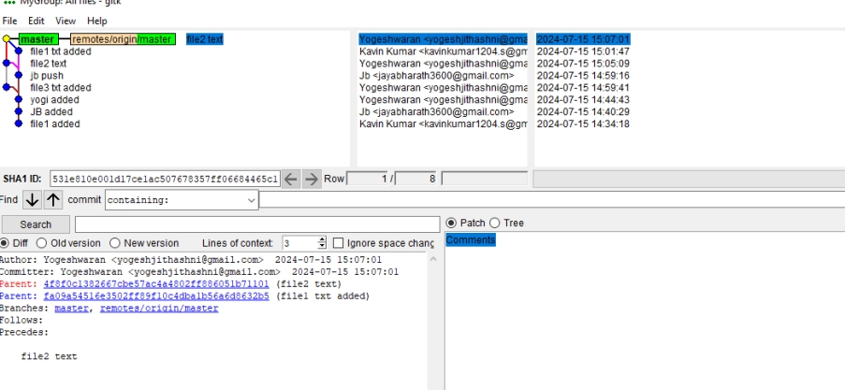

Exercise 4

1. Make a commit, and make a silly typo in the commit message.

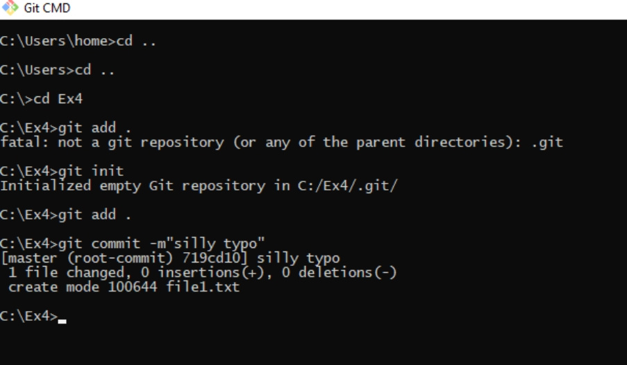

2. Use the --amend flag to enable you to fix the commit message.

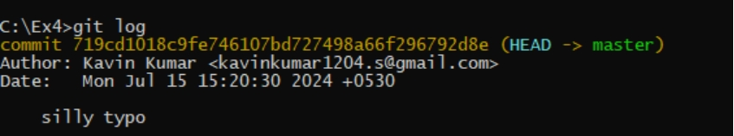

3. Look at the log and notice how the mistake is magically gone

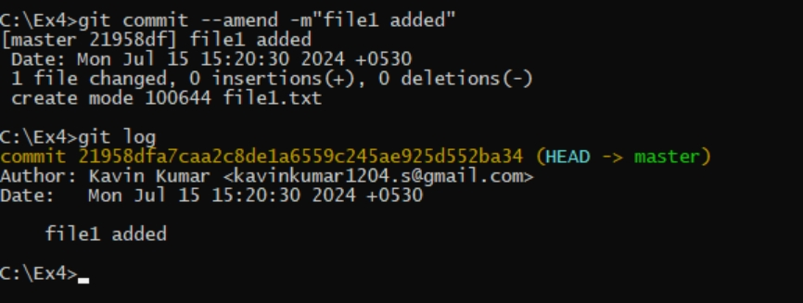

4. Now make a commit where you make a typo in one of the files. Once again, use --amend to magic away your problems.

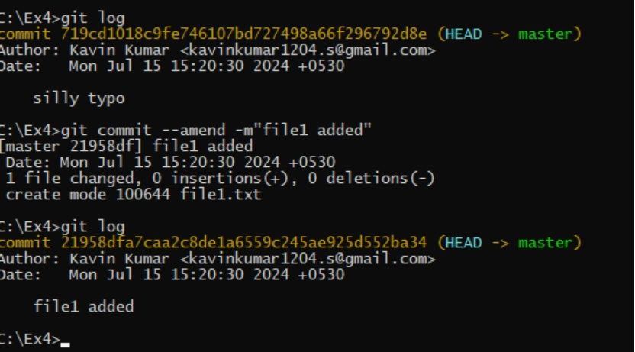

5. Create a branch. Make a commit

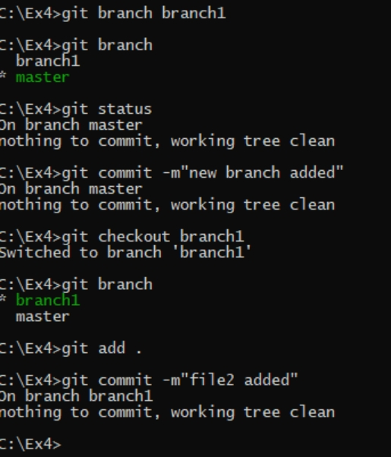

6. Now switch back to your master branch. Make a (non-conflicting) commit there also.

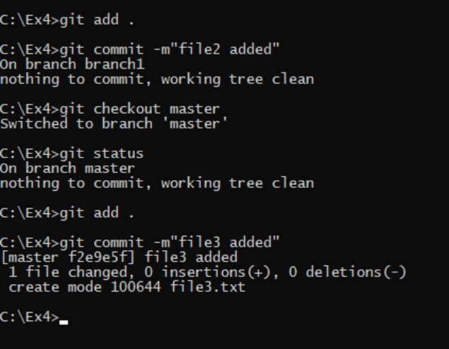

7. Now switch back to your branch.

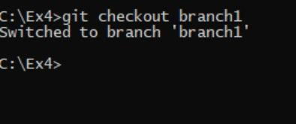

8. Use the rebase command in your branch. Look at the DAG in gitk, and note that you have the commit from the master branch, but no merge commit.

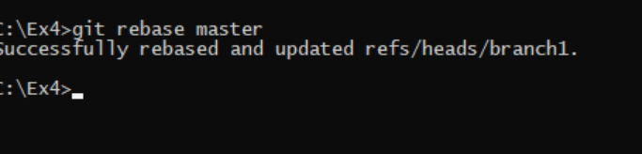

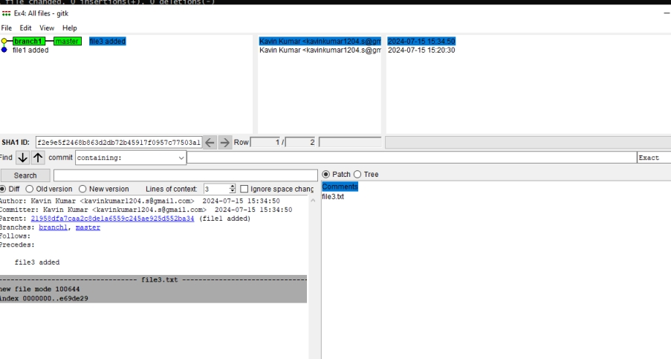

9. Make one more commit in your branch

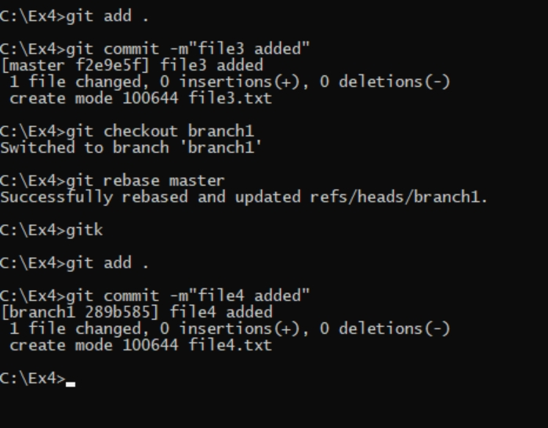

10. Return to master. Merge your branch. Notice how, thanks to the rebase, this is a fastforward merge.

